MAD SEMESTER Project Report

**Hammad Ahmed Ahmed**

**BSCS-VII, Sec ’A’**

**CMS-ID: 021-19-0018**

**Title: Radio Application**

**Introduction:**

A Flutter Radio App which plays online radios worldwide for different features with the help of the Internet Radio plugins and URLs.

**Technologies used:**

* VSCode IDE
* Flutter Platform using DART.

**Methodology:**

To run this app follow the instructions:

1) Clone this repository or download the zip file.

2) Run "flutter pub get" in terminal to install the the libraries required for the project to run.

3) Select any Android Emulator or a debug android device connected with wire with OTG settings "ON".

4) After successfull connection with the device, press the F5 to initiate the app building process and wait for the APK file to be build and installed on your device.

5) If you want to run the app in a chrome browser, enter "flutter run -d chrome" command.

**Some Screecshots of Application Running on Chrome:**

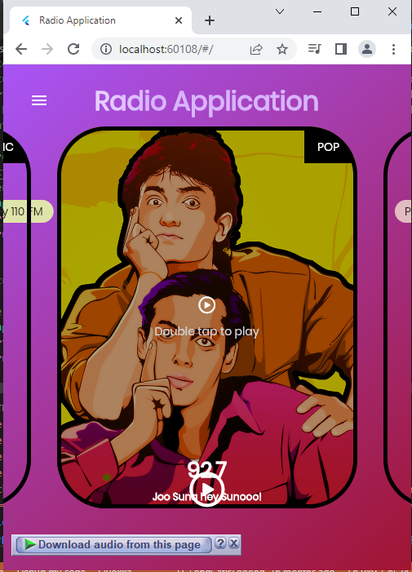

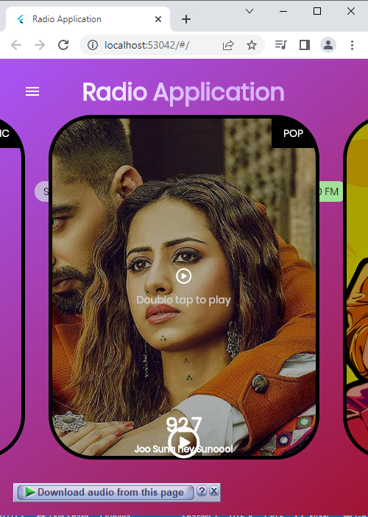

**Video Link:** <https://drive.google.com/drive/folders/1u65WvB3ENTkfGjTbVgJva9OY98Kv4ZAh?usp=share_link>

**Project Code GitHub Link:**

<https://github.com/Hammad-Ahmed192000/Mobile-Application-Development/tree/main/MAD%20Semester%20Project/airadio>

**GitHub Link for all Course (MAD) Material:**

<https://github.com/Hammad-Ahmed192000/Mobile-Application-Development>